**Load Iris Dataset and analyze**

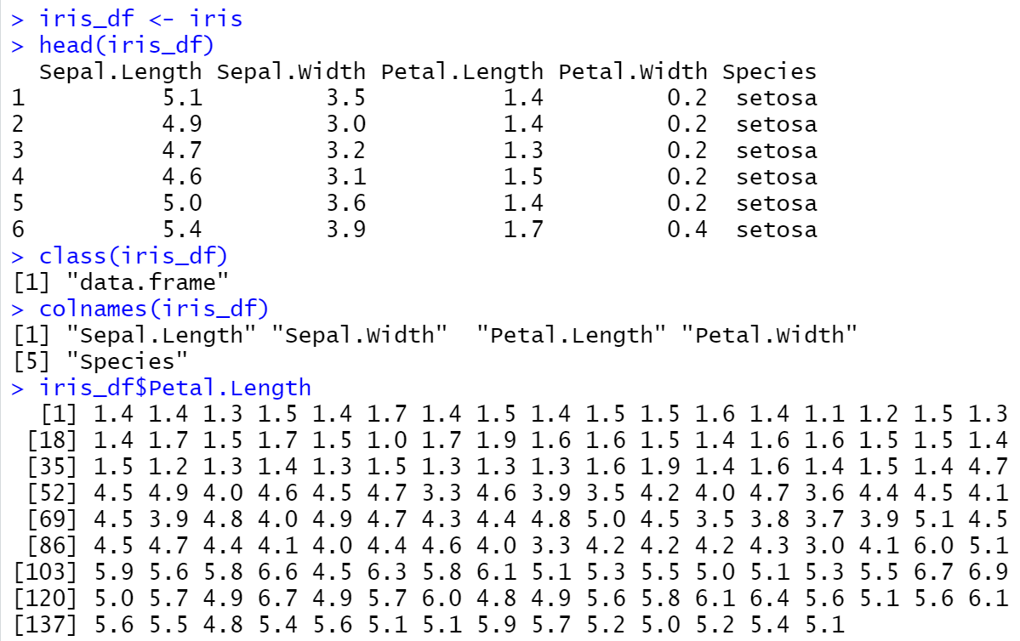

**Summary:**

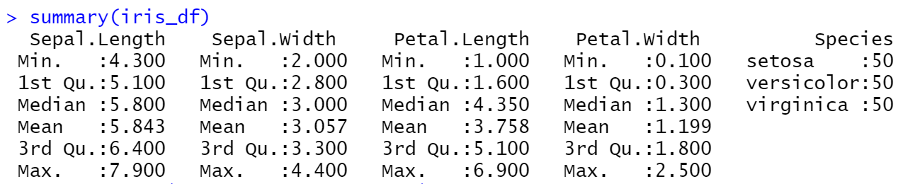

**plot(iris_df$Petal.Length, iris_df$Petal.Width, main="Iris Data")**

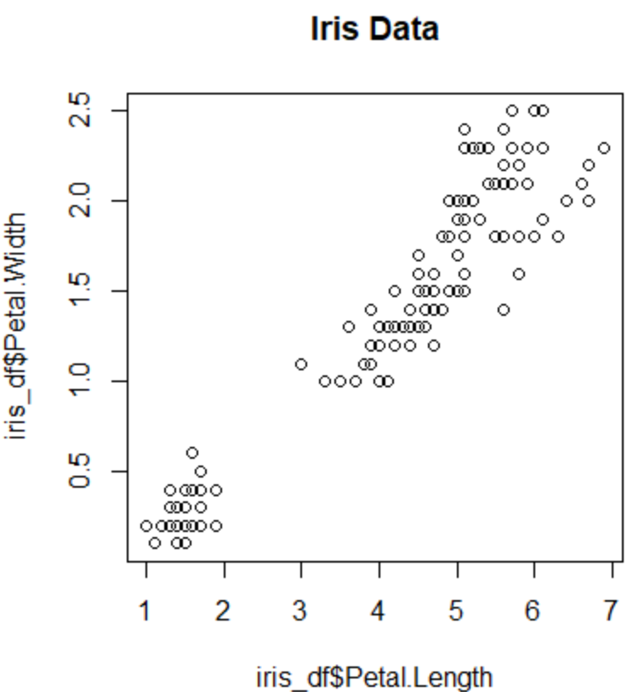

**plot(iris_df$Petal.Length, iris_df$Petal.Width, pch=c(21,23,24)[unclass(iris_df$Species)], main="Iris Data")**

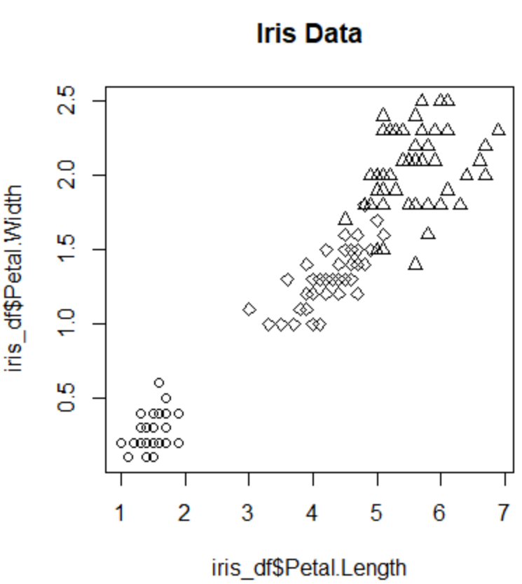

**plot(iris_df$Petal.Length, iris_df$Petal.Width, pch=21, bg=c("red","green","blue")[unclass(iris_df$Species)], main="Iris Data")**

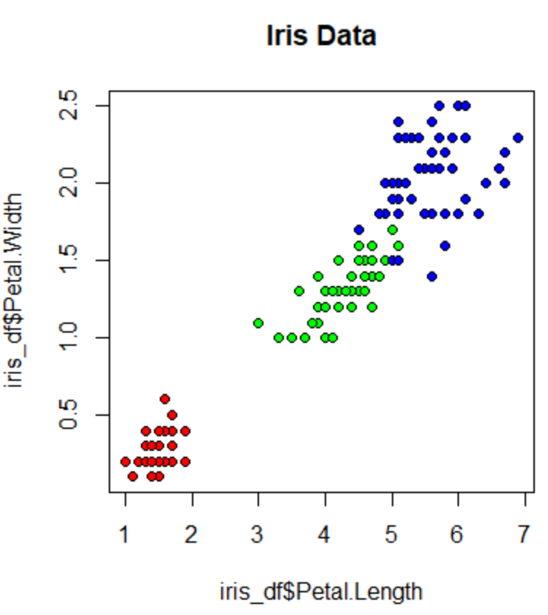

**boxplot(iris_df$Sepal.Length, main="Box plot", ylab="Sepal Length")**

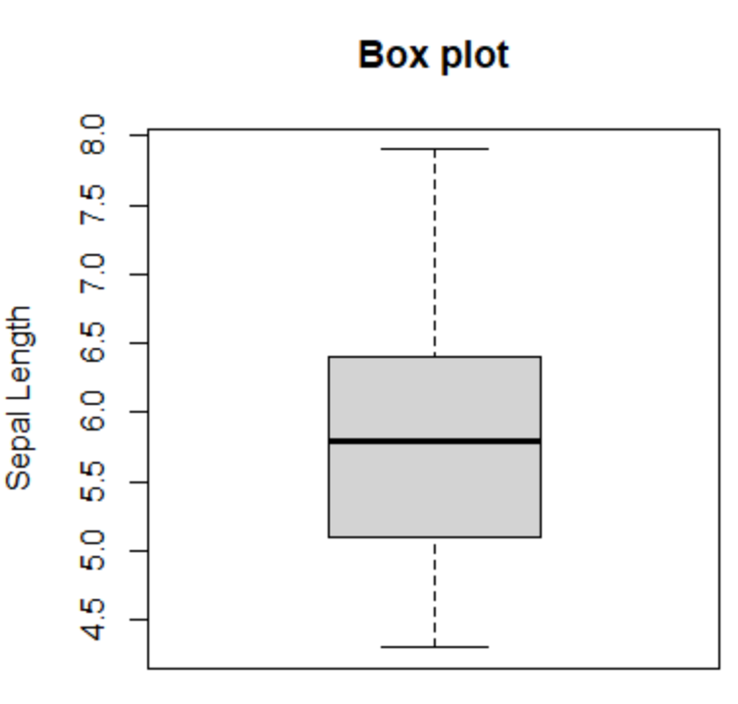

**boxplot(iris_df$Sepal.Length ~ iris_df$Species, main="Box Plot", xlab="Species", ylab="Sepal Length")**

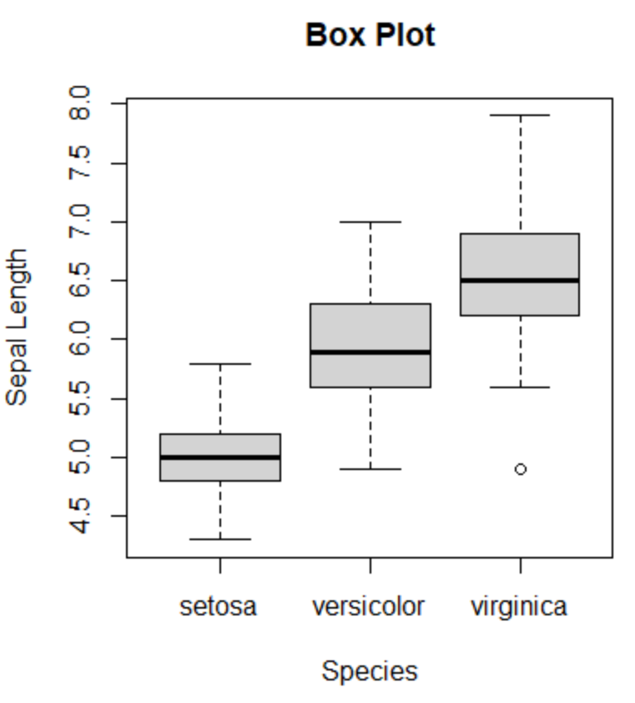

**hist(iris_df$Sepal.Length, xlab="Sepal Length")**

